Linear Regression Analysis of GDP vs Population
Name: Dharmik Godalka
Roll No: 92400133054
Case Study: 4th

Introduction:
Linear regression is a method used to find the relationship between two variables. In this project we learn how population of India affects its GDP. GDP is the total value of goods and services produced in a country.
Objective:
- To analyse the relationship between GDP and Population
- To apply Least Squares Linear Regression Method
- To plot graph and understand the latest time trend

Data Collection (and Cleaning):
The data of GDP and Population from 1980 to 2021 is collected from government and official online sites. For better understanding population is taken in billions and GDP in trillions.

Mathematical Formula:
The linear regression formula is:
Y = mX + c
Where, m = slope
c = intercept

Other Formula:
m = (nΣXY − ΣXΣY) / (nΣX² − (ΣX)²)
c = (ΣY − mΣX) / n

Sample Calculation:
For a few simple values:
X (Population) | Y (GDP) | X^2 | XY
x₁ | y₁ | x₁² | x₁y₁
x₂ | y₂ | x₂² | x₂y₂
Then, ΣX = x₁ + x₂ + ...
ΣY = y₁ + y₂ + ...
ΣXY = x₁y₁ + x₂y₂ + ...
ΣX² = x₁² + x₂² + ...
Substituting these values in the formula:
m = (nΣXY − ΣXΣY) / (nΣX² − (ΣX)²)
c = (ΣY − mΣX) / n
The values of m and c are calculated using the above formulas.
Methodology:
The data is first loaded using Python and scaled for better usage. The Least Squares method is applied to find the regression line, and predicted values are calculated. Finally a graph is plotted using matplotlib to show the relationship between population and GDP.

Code:
import pandas as pd
import matplotlib.pyplot as plt

df = pd.read_excel("Orginal Data.xlsx")

X = df["POPULATION"] / 1e9
Y = df["Gross Domestic Product"] / 1e12
n = len(X)

sum_x = X.sum()
sum_y = Y.sum()
sum_xy = (X * Y).sum()
sum_x2 = (X * X).sum()

m = (n * sum_xy - sum_x * sum_y) / (n * sum_x2 - (sum_x ** 2))
c = (sum_y - m * sum_x) / n
pred = m * X + c

sorted_indices = X.argsort()
X_sorted = X.iloc[sorted_indices]
pred_sorted = pred.iloc[sorted_indices] plt.scatter(X, Y)

plt.plot(X_sorted, pred_sorted, color='red')
plt.xlabel("Population (Billions)")
plt.ylabel("GDP (Trillions)")
plt.title("GDP vs Population")
plt.show()

Result:
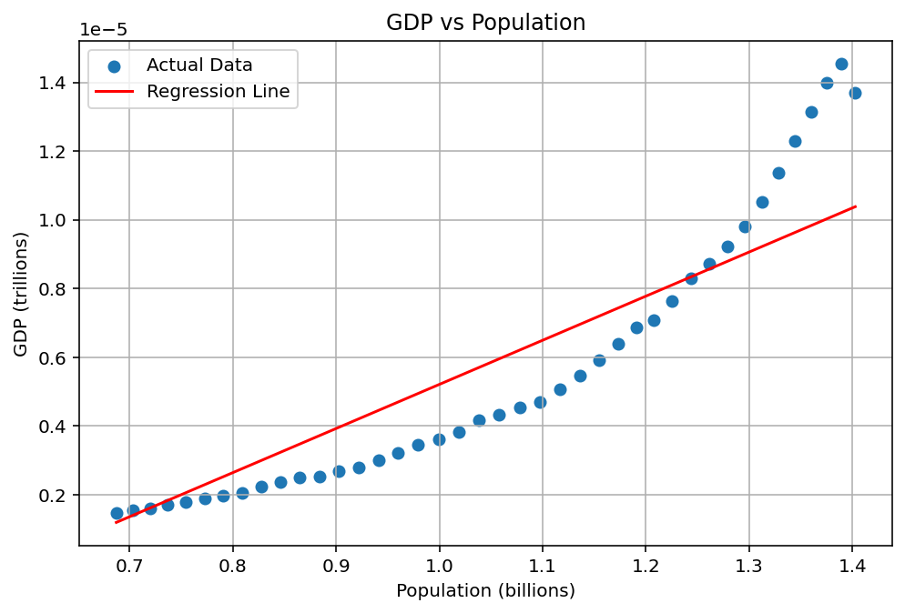

The graph shows that GDP increases as population increases. So, there is a positive relationship between them. However, the growth is not perfectly linear. At the last stage, a small decrease in GDP is observed due to real-world factors like economic slowdown (for example, CORONA or any other changes).

Conclusion:
From this case study, we conclude that GDP and population are positively related. Linear regression helps to understand the overall trend using Least Squares method but real data may have small variations.

References:
https://data360.worldbank.org
https://censusindia.gov.in
https://data.rbi.org.in

